**Step 1: Empathize**

**Identify your client and the purpose of your website, who is your target audience?**

* My client is George Furst. A professor that I know from Korea that enjoys hiking and canoe.
* A quote from the client “My ideal is to have a website that would come up if a foreigner googles mountains of Korea or something similar. I also plan, as I said yesterday, to do a similar project on canoeing the rivers of Korea. They are a wonderful resource for recreation that is terribly underutilized.”
* The purpose of the website is therefore to help people, especially foreigners living in Korea to find out more about Korean mountains and rivers.
* It was also mentioned that in the future he wants to write a book about his experiences of hiking and canoeing in Korea. Therefore, will also have some information about him
* He is part of a group of foreigner hiking group and would also like to promote this group on his site

**Relevant Implications**

* **Aesthetics**
  + Navbar should sit on top of the page and the links should sit either on the left/right-hand side of the logo or menu
  + Have a clear contrast of front e.g. white background with black font
  + Keep the design minimal, use white space to ensure the design is not cluttered
  + Rule of thirds - the top third should contain the nave bar and dominant image; the main section should be your content and the last sections should contain a footer with copyright info and links.
  + The font should be scalable so that I easy to read across devices.
* **Accessibility**
  + Make sure your page can scale across multiple devices e.g. tablet, PC and phone using media queries
  + Use alt tags on image for blind people
  + Meta tags in the head section, give a decent description so the search engines   your site
  + Hyperlinks should be obvious, have hover effects of some kind and should work
* **Future Proofing and sustainability**
  + Code comments to help future coders understand your code
  + Use DIV tag rather than HTML5 tags to ensure a consistent and accurate design
  + CSS3 is the most up to date style sheet
  + Avoid using plugins
  + In the footer, note the year the site was created and by whom so users know it is up to and can contact you
  + Keep updating content to ensure that your information is correct

**Client specifications**

* Home page with general information and about me section
* Hiking page with each mountain getting its own sub-page
* Canoeing page with each river getting its own sub-page
* A page with information about his hiking group
* Responsive design for desktop and mobile
* Use of the provided photos

**Step 2: Define**

index.html

canoeing.html

mountain.html

about_us.html

(1 page for each mountian).html

(1 page for each river).html

**s**

**Evidence of written permission**



**management of files**

within my folder I added the 4 main html pages and my CSS file for all of the sites. I then created a folder for the multiple canoeing html pages and mountains html pages I will have in order to not have 20+ html files all in one folder

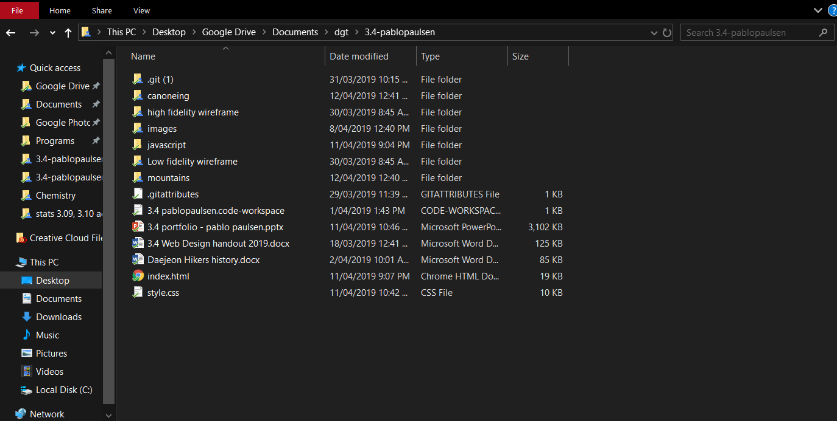

**Images**

* All of my photos for index and Daejeon hikers page will go straight in to my images folder. However, in order to not have 1000s of unorganized photos each page about each mountain and river will get its own folder.
* In order to load the page as fast as possible I used googles <https://squoosh.app/editor> web image compressor as it uses good compression algorithms designed for websites allowing me to get smaller file size for a quality image. For parallax image I made the image width to 1920px as this is the width of the commonly used higher resolution monitor using resize method Catmull-rom. I used mozJPEG with 60% quality as this is the lowest, I could go without artefacts showing up in images. This allows for file size generally below 250kb. For regular image I set the size to max width and max height to be 1280px with quality of 70% in order to avoid artefacts that could make the image harder to read.

**Data Integrity Gather content – proofread and edit**

* I read over and check the spelling and grammar of all of the word documents

**Step 3: Ideate**

**Font Combinations**

* I choose to use titillium web for nav bar links and heading while using open sans for regular text

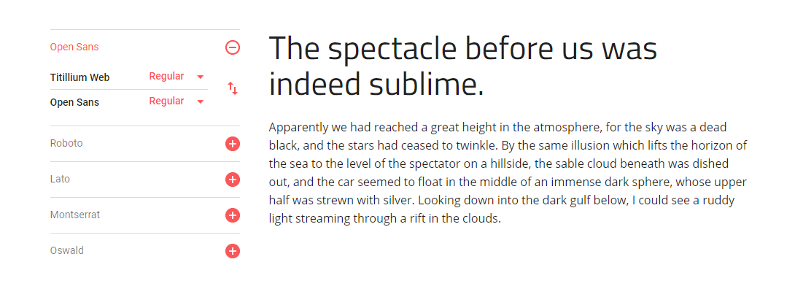

**Colour combo**

**Low fidelity wire frames**

**Wire frame 1:**

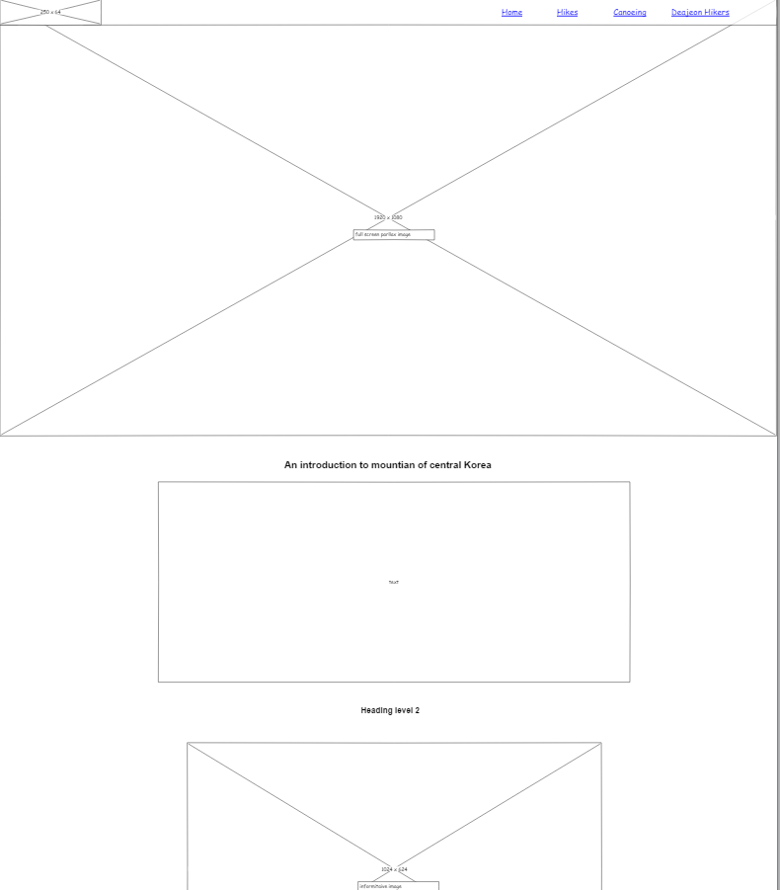

**Feedback received:**

* The images are too big and covering most of your page. I like the parallax. Your footer is too big for your lack of content.
* Banner image as well as the navbar look nice and would be easy to scale for mobile. Parallax images look nice but some of the images are too big. Footer has quite a lot of empty space, could use some extra content. Could in some cases combine parallax effect with the h1 tag to reduce very large page height.
* David – Nice use of white space and divs on multiple parallax images. Links on nav links seem far away from links. Footer seems very asymmetric.

**Wire frame 2:**

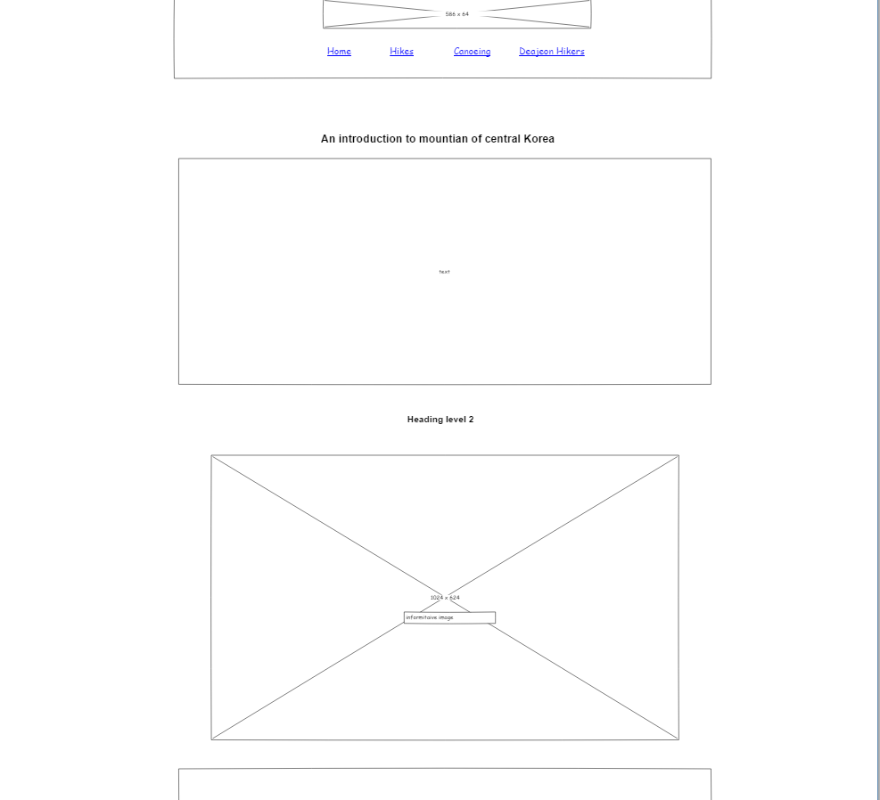

**Feedback received:**

* David - Lots of content. Imagery covers most of the page. Nav bar appears really pushed in.
* Jack – Navbar doesn’t work well being centred. Also, image looks really stretched. Lots of images that seem random. Lots of dead space in footer. Image slider that is not on other page is a good idea

**Response to feedback**

* Overall design 1 has much better feedback especially around the nav bar therefore for I will keep design 1 with some updates to the feedback
* I received feedback saying that my images were too large. So, I reduced the size of some of the images where possible
* I also received feedback saying that footer was too big. So, I reduced the height of the footer in order to reduce white space
* I also reduced the spacing between the links a little bit
* I also am considering adding the image slider that received positive feedback to replace the top parallax image on design 1 or add it to another page where more images could be required

**Changed low fidelity wireframe**

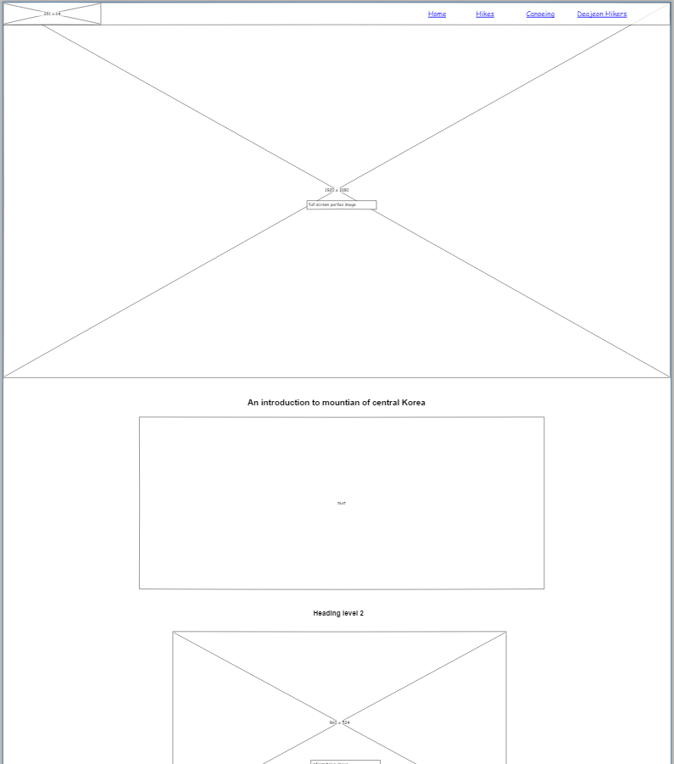

**High fidelity wireframe**

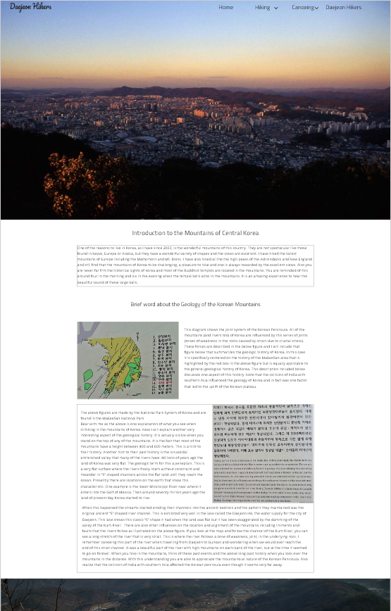

**Step 4: Protype/ Testing**

**Evidence of iterative improvement**

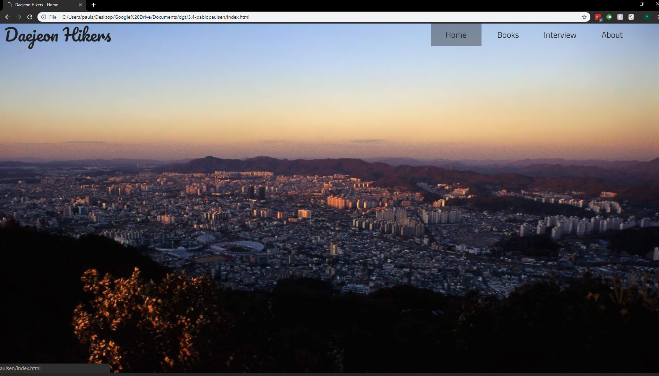

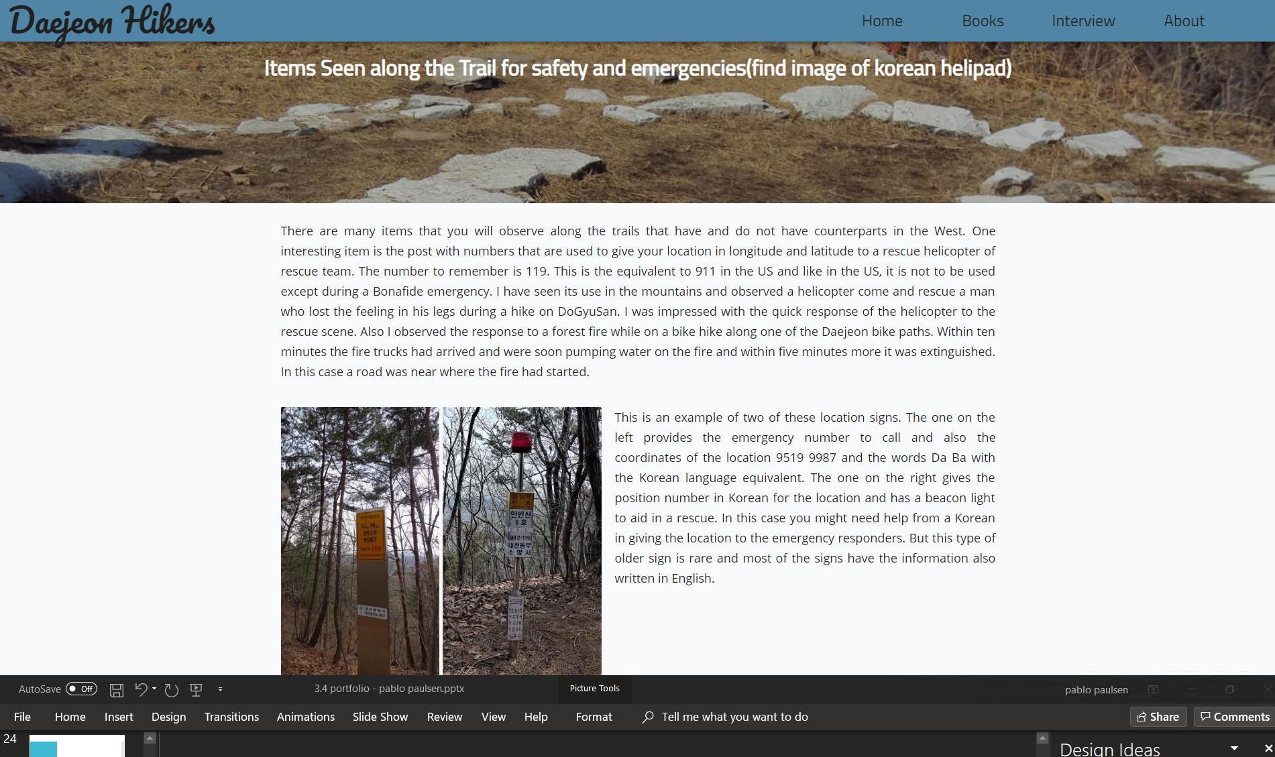

**Feedback**

* Jack Olsen: Navbar has good font choice, however I would change the hover effect. The grey block behind it doesn’t look good with the image. A lot of empty space in some of the paragraphs with images. In mobile view it would be nice if you had a sticky nav, as the top nav disappears and to go to a new page after scrolling to the bottom you would have to scroll all the way up. Maybe you could have a scroll to top as the page content is very high.
* **Zac**
* I am concerned with the white space
* Lots of writing and in some cases no breaks for long time
* I Like the parallax effects and hover effects.
* Maybe have a h2 or h3 heading as the top with space below to reduce your whitespace.

**Response to feedback**

* I changed the hover effect of the nav bar links so that instead of background colour change text colour changes
* I also change the mobile navbar so that its position is fixed
* Will be testing and comparing a new card layout for the content in order to reduce white space

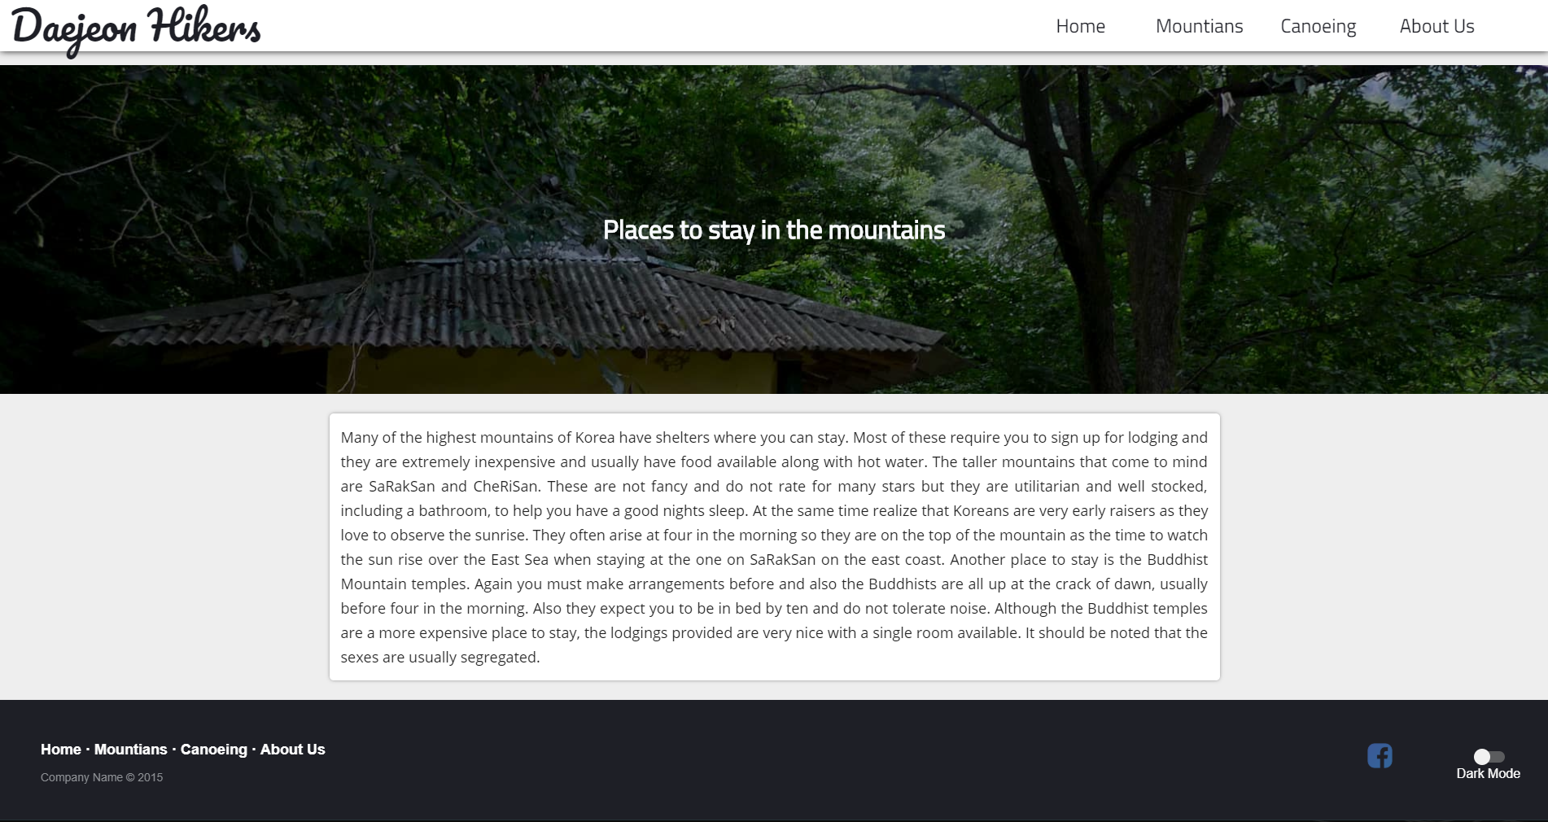

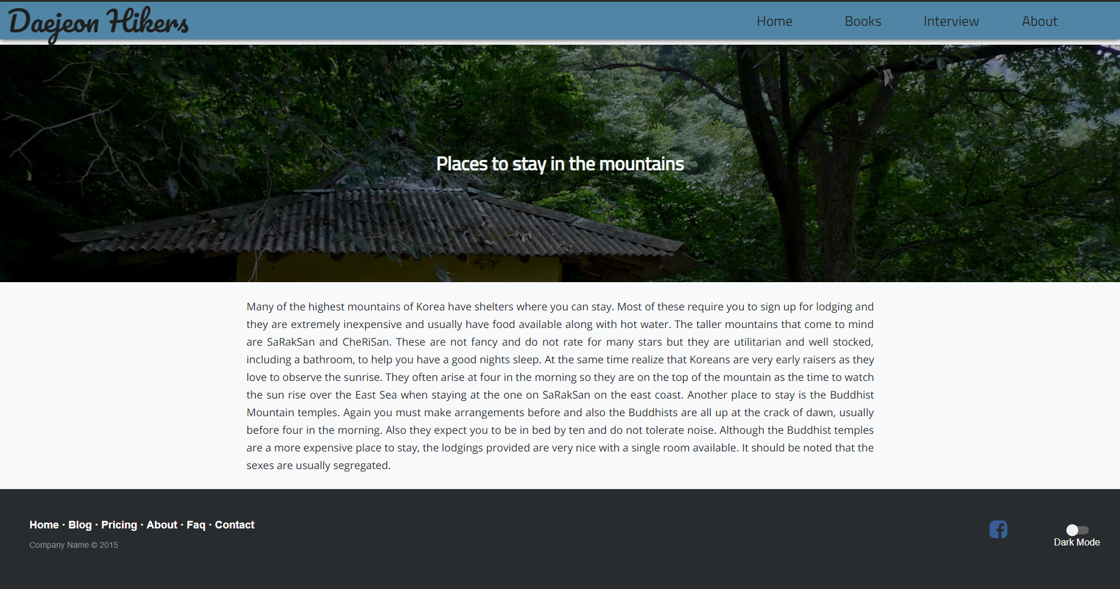

* Abdu
  + I like the page that has cards. The only thing about the card it that the text seems a bit too close to the edges of the card
  + Your font doesn’t seem to fit the title font and seems a bit off.
  + The second page has a very plain colours whereas the first page has more than one accent colour.’
  + I like the h1 tag colours. It’s not too dark and it’s not black which makes it stand out more and less at the same time.

**Response to feedback**

* as the card layout had more positive feedback, I will keep the new card layout
* Made a more even 24px padding on the content cards to space out the text and images on the card better

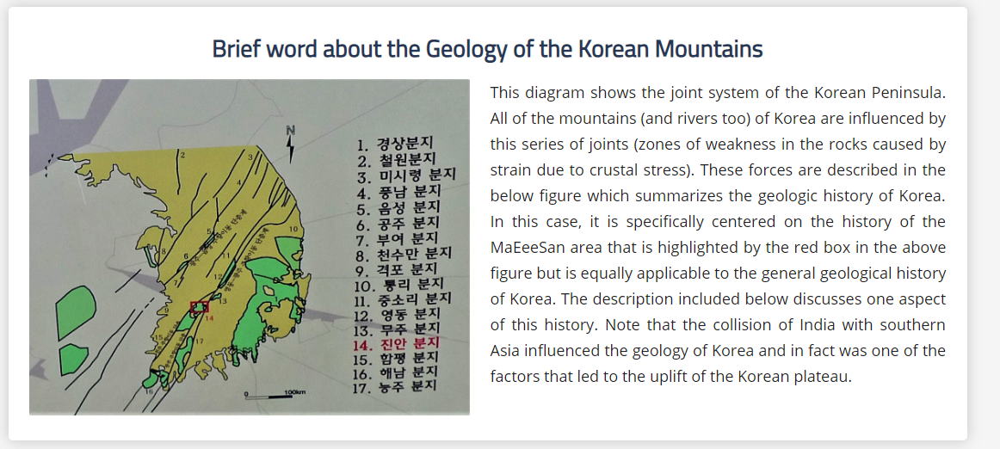

**A vs B testing: headings**

* A

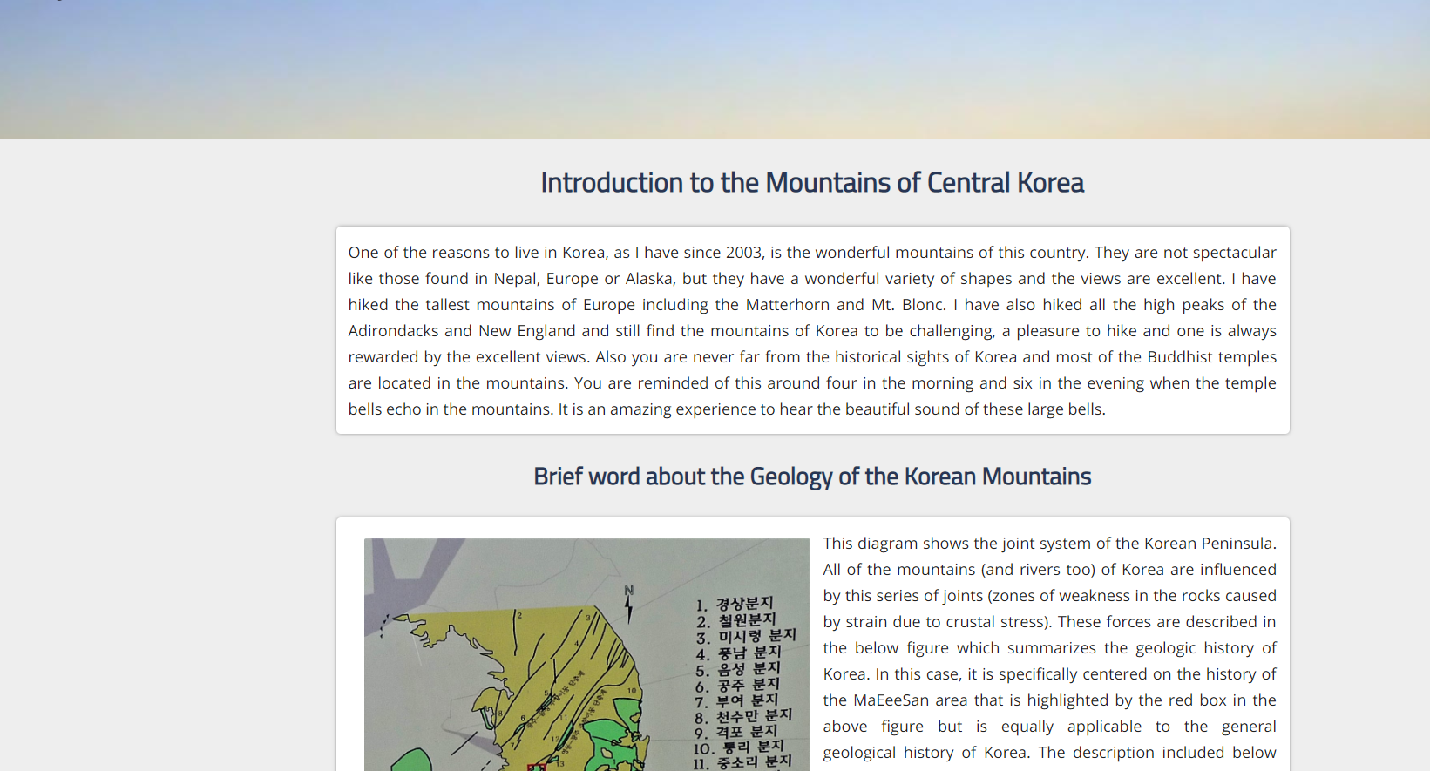

* B

**Feedback**

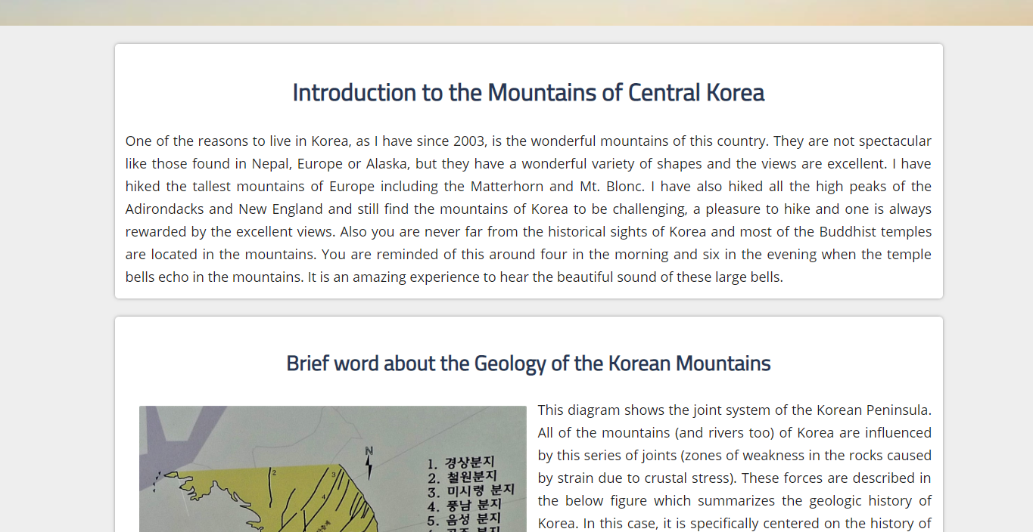

**Feedback**

* Abdu
  + I like the page where the header is inside the card.
  + If you were going to put the header outside the card, you should move the header closer to the card.
  + Add more padding above and below cards and text.
* Jack
  + Paragraph text looks a lot better with the header in the box.
  + Add more padding below and above the cards.

**Response to feedback**

* I received more positive feedback on when the heading is inside the card therefore, I will keep this design
* I spaced out the padding around the card and text

**A vs B testing: footer**

* A



* B



**Feedback**

* + I prefer the top footer. The copyright statement under the links with the lighter grey text is well done. Compared to the black copyright statement under the Facebook link. The white text on dark background is very professional looking. The Facebook logo could have a white f maybe.
  + I also prefer the top footer. The text colour of the bottom footer seems a bit too dark. The gap between the dark mode icon and the Facebook icon is quite large. You should add another icon with the Facebook logo, because one just seems a bit lonely

**Response to Feedback**

* As the top footer with the copyright text below the links received better feedback, I will keep this design
* As there is no other social icons that my client requires I cannot add any other social icon. I however did replace the icon with a white only icon done by SVG. This improves loading time compared to an PNG as no image is required to be downloaded and fits the design of the other elements in my footer better and I also moved it closer to the dark mode switch in order to make it feel less “lonely”
* 

**A vs B testing**

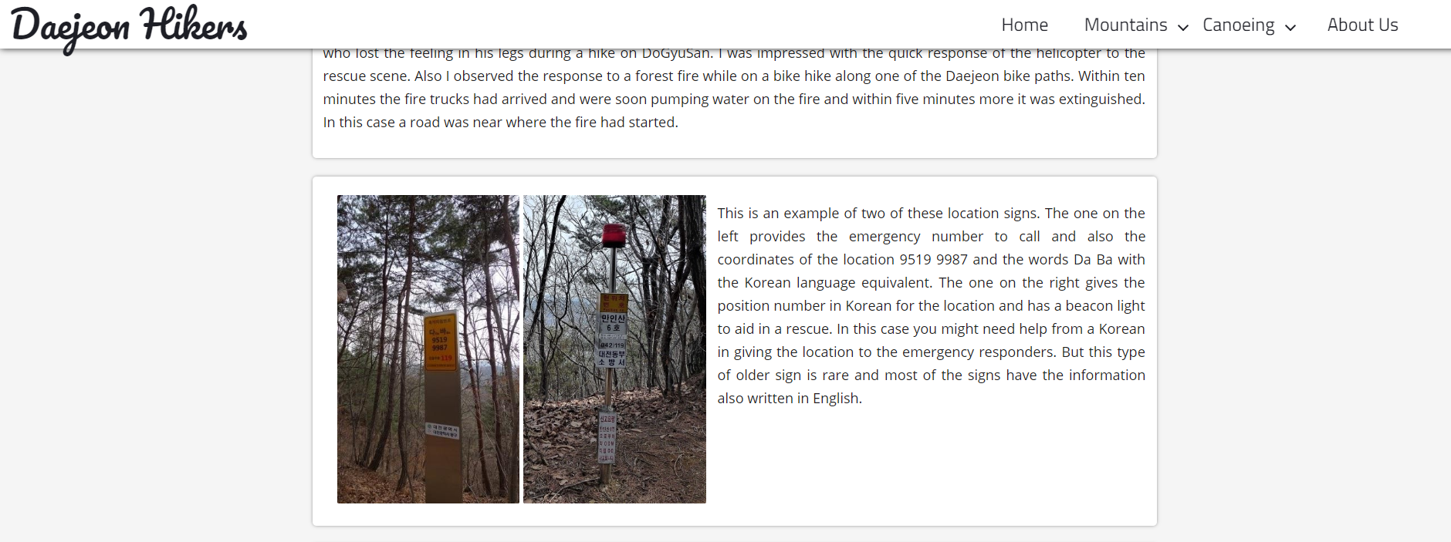

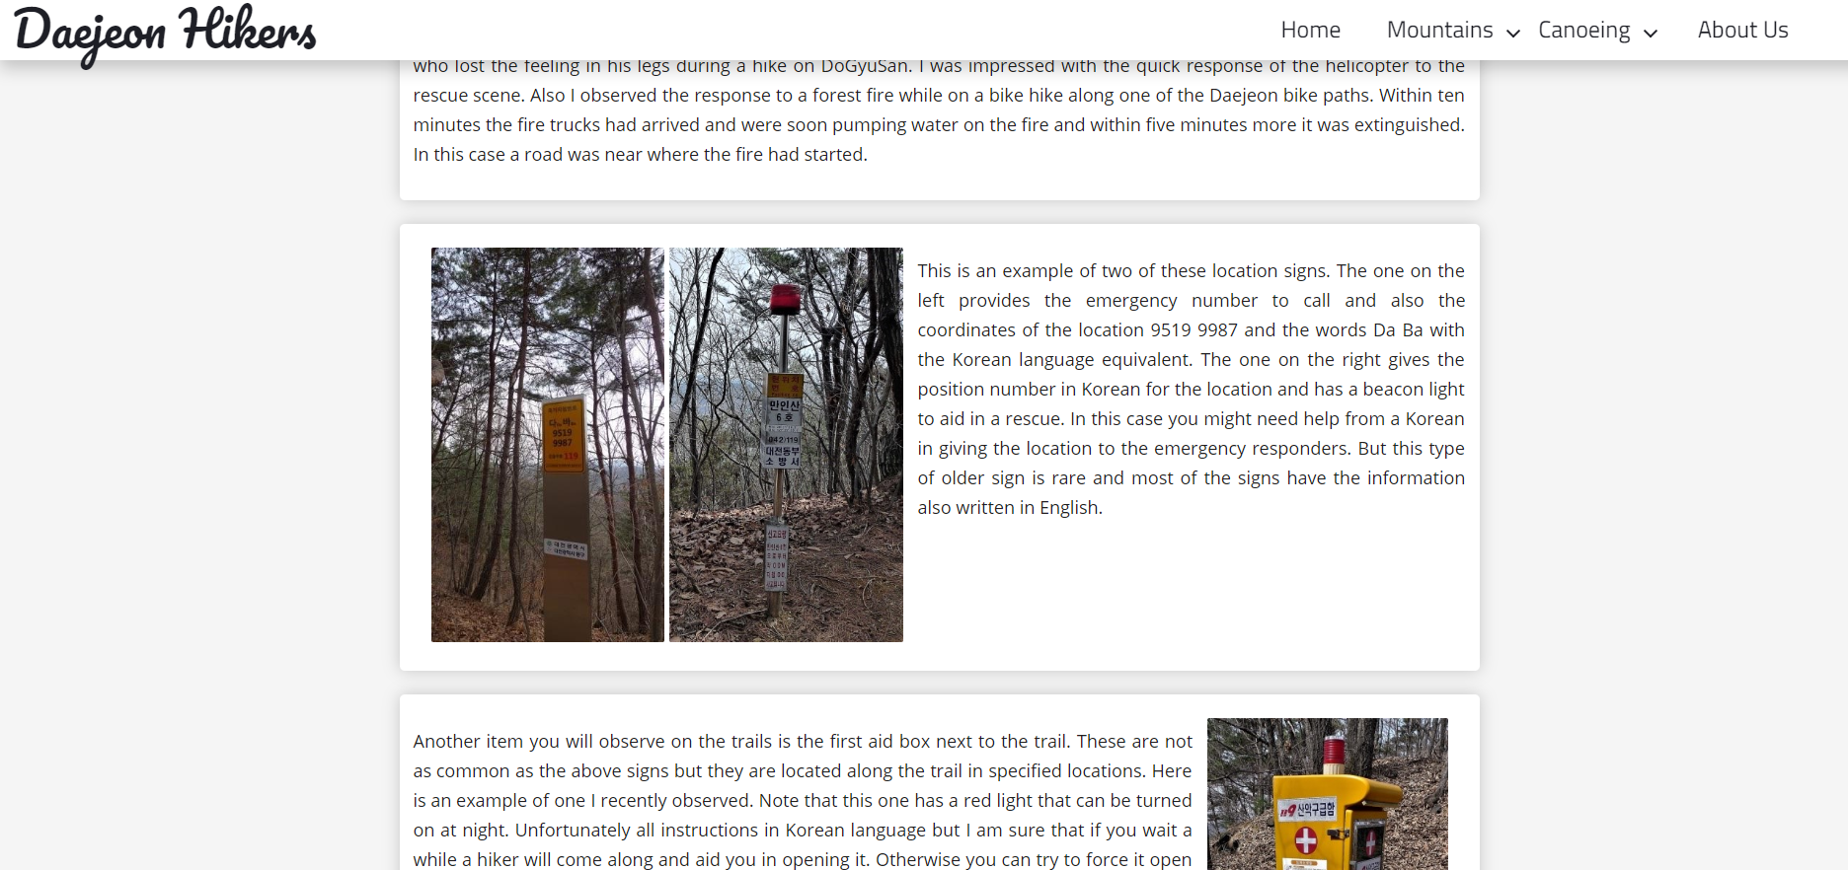

**Feedback**

* Zac

I personally prefer the shadow of the bottom image. As it gives a more clear separation of the nav bar and the content. While on the top it is more difficult to see. 뭉 moreover I see that the J in the image on the top left goes past the shadow slightly, which to me looks irritating when compared to the other.

**A vs B testing**





**Feedback**

I personally prefer the bolded text over the non bolded text as it makes it more easily to differentiate over the normal text. And I just like it, As the other one has the text harder to read when having a white background,

Zac

**Initial design of dark mode**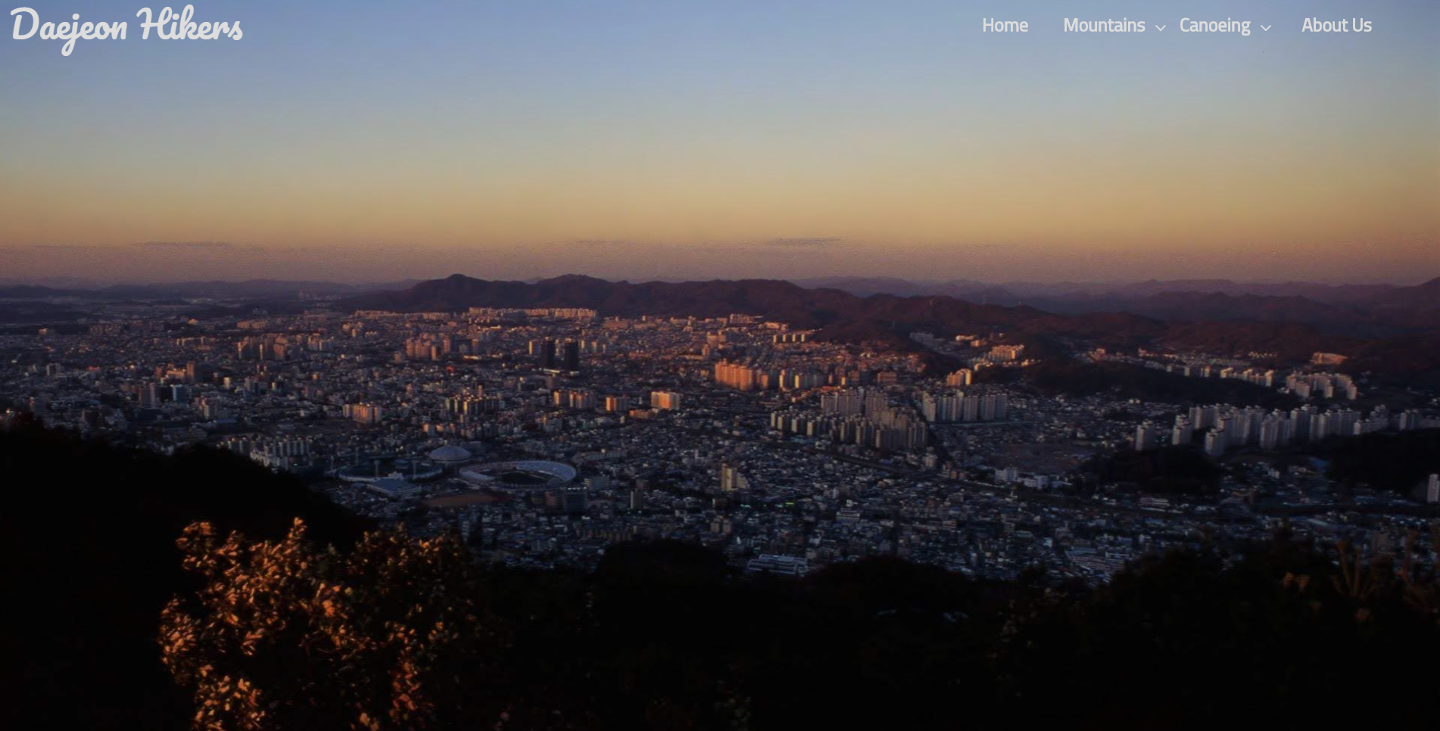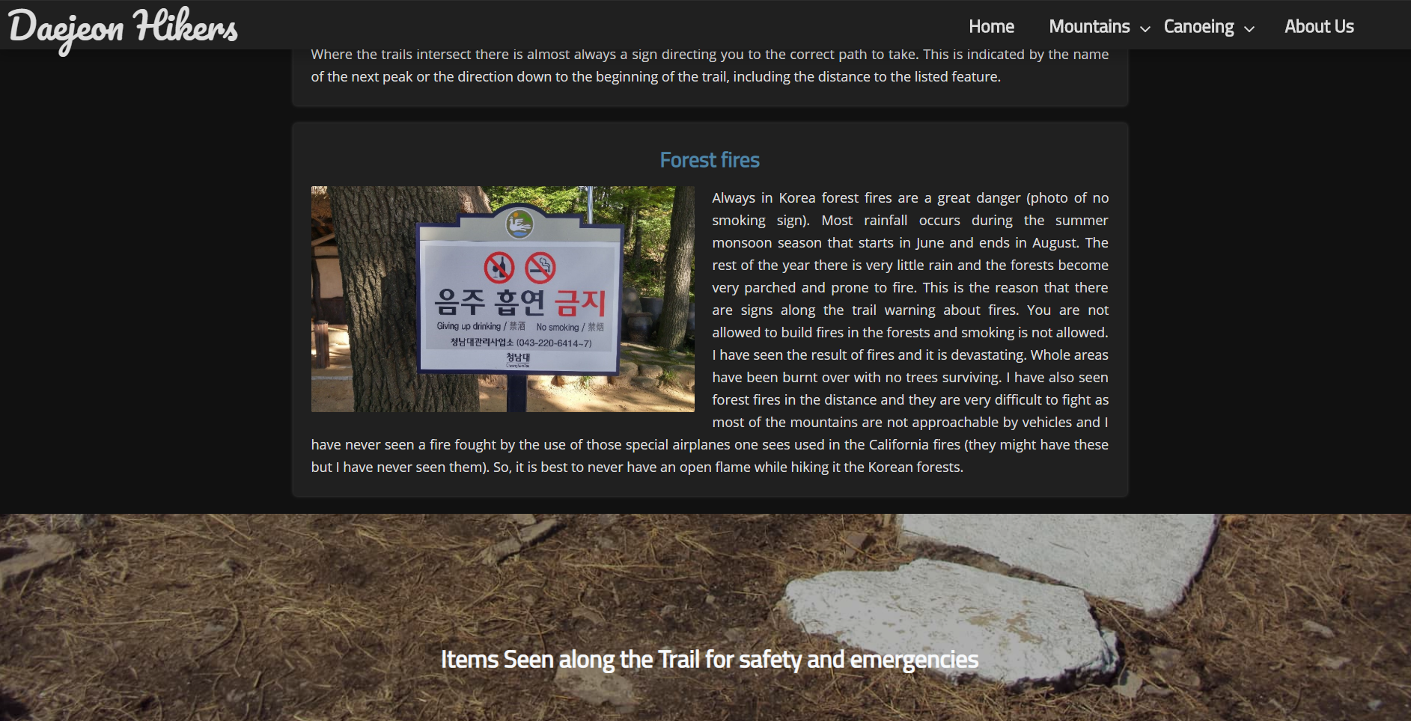

**Feedback**

I find it hard to rad the text in the nav bar as it is easily swamped by the background. . however ina dark situation I would prefer this over a lighter theme. Meaning that is an essential part in the accessibility ofr a usrer

**Initial Dropdown menu**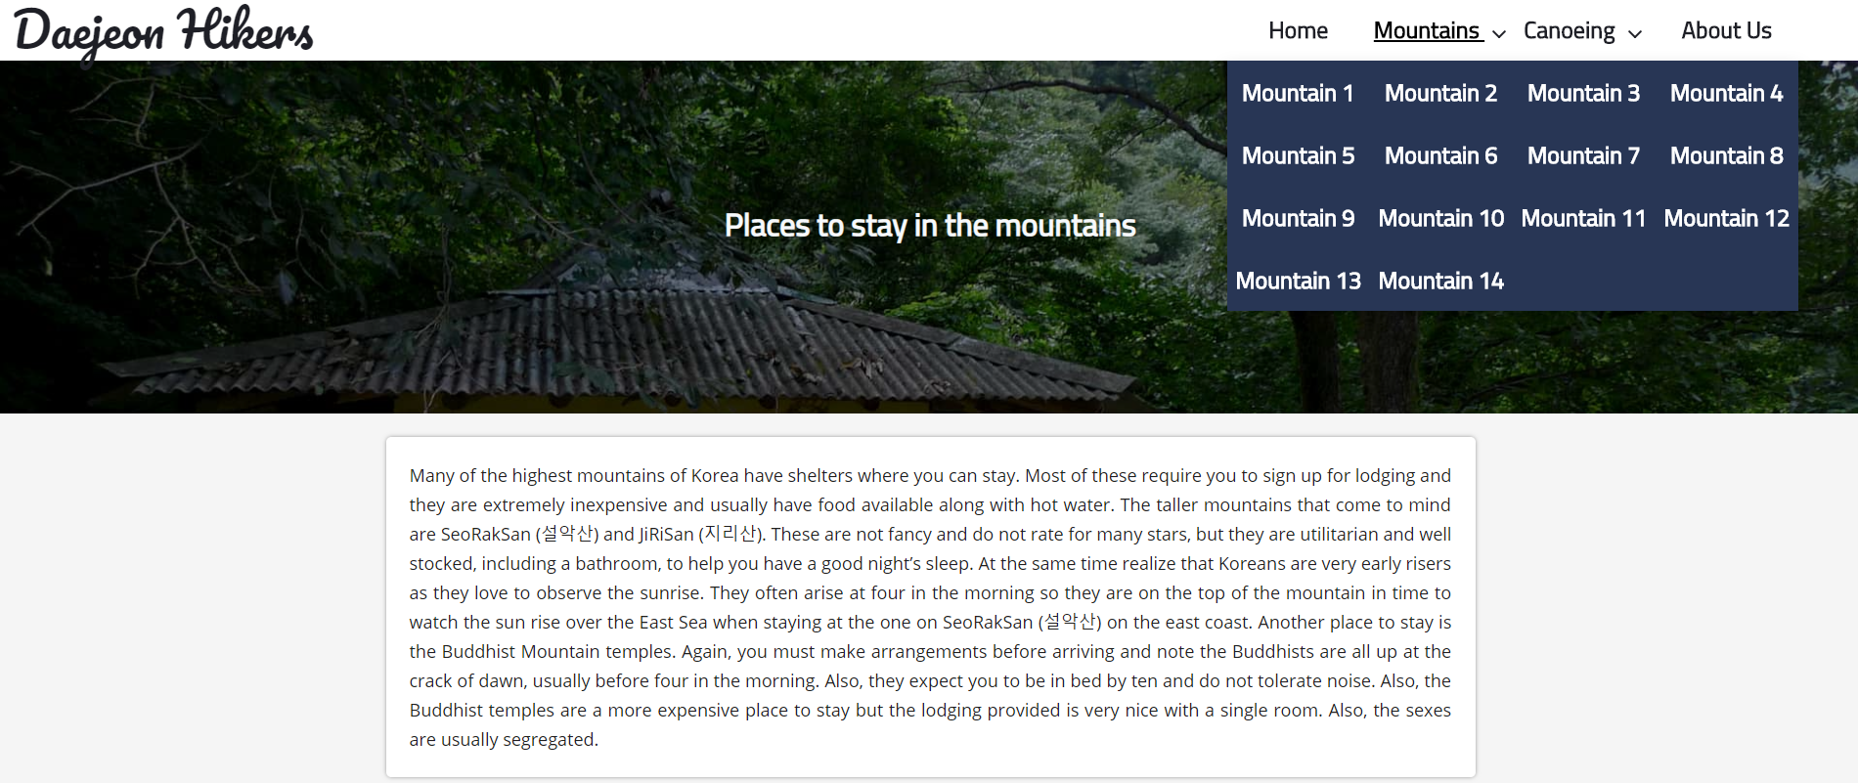

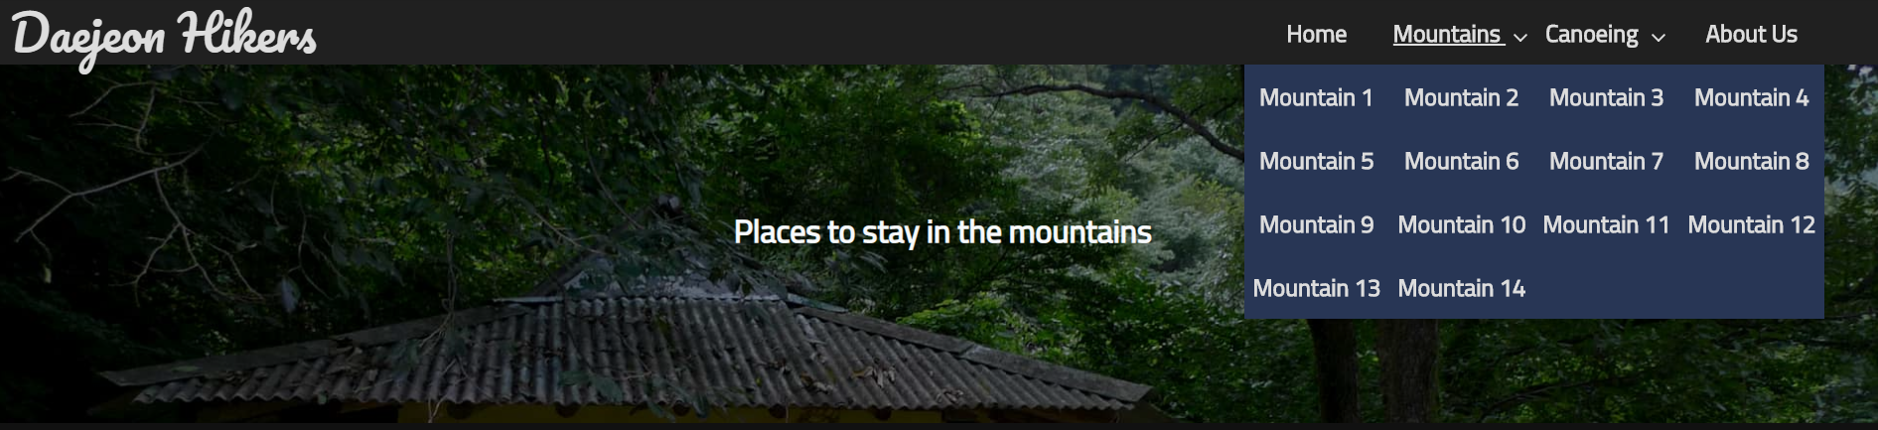

**Feedback**

* **I don’t like the colour it should be something else that matches the top of the nav bar. I don’t the underline under the mountain. Maybe just have to animate to a different colour such as grey.ZAc**

**Testing Procedures: performance**

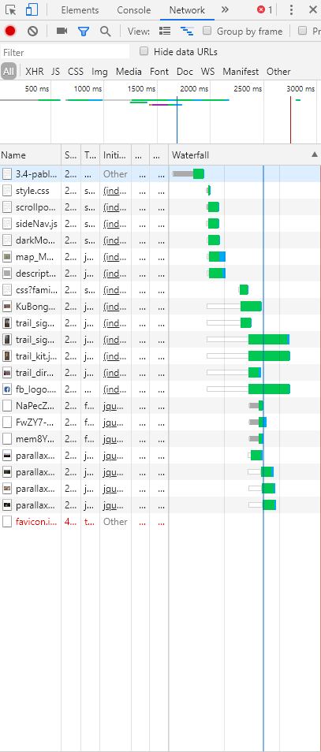

* I hosted my website using git hub in order to check the loading speed and any files that may take longer to load. As all my files are compressed Loading time was short and only 1.9mb was downloaded which means even with a 5mbps internet connection the site should only take 4 seconds to load
* 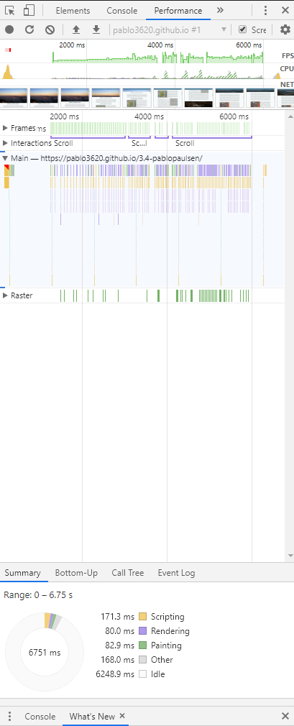
* I then check performance and noticed some frame dropping and computer fan spinning up. If hardware acceleration is disabled, this becomes worse as I experienced frame rates below 15fps. As some people do not use hardware acceleration, I need my website performing well for these users. In order to find the cause of the issue i used chrome developer tools and found that my scroll function was taking very long time to change the style. After some testing I realized that my parallax image blurring as you scroll was causing the performance issues, so I disabled it.